OS LAB -CPU SCHEDULING

FCFS
#include<stdio.h>
int main()

{
int n,i,j;
float avwt=0.0,avtat;
printf("Enter total number of processes:");
scanf("%d",&n);
int bt[n],at[n],wt[n],tat[n],ct[n];
for(i = 0; i < n; i++)
{
printf("\nPROCESS [%d]\n", i);

printf("Enter Arrival Time:");

scanf("%d", &at[i]);

printf("Enter Burst Time:");

scanf("%d", &bt[i]);

}

ct[0] = 0;
for(int i=1;i<=n;i++){
ct[i]=ct[i-1]+bt[i-1];
}
//turn around time=completion time - arrival time
for(int j=0;j<n;j++)
tat[j]=ct[j+1]-at[j];

printf("\nProcess \tBursttime \tWaitingtime\tTurnaroundTime");
//waiting time=turn around time - burst time
for(i=0;i<n;i++)
{
wt[i]=tat[i]-bt[i];
avwt+=wt[i];
avtat+=tat[i];
printf("\nP[%d]\t\t %d\t\t %d\t\t %d",i,bt[i],wt[i],tat[i]);
}

avwt/=n;
avtat/=n;
printf("\nAverage Waiting Time:%f",avwt);
printf("\nAverage Turnaround Time:%f\n",avtat);}

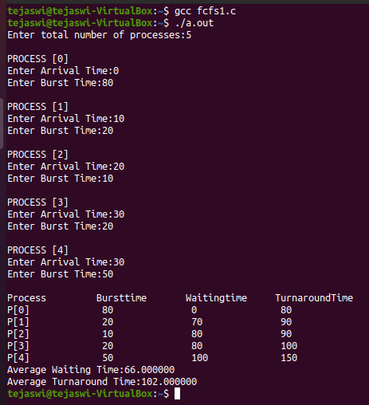
SJF
#include <stdio.h>

int main()
{
int n,i,s,j,c=0,tta=0,twt=0,temp;
float atat,awt;
printf("Enter number of processes : ");
scanf("%d",&n);
int p[n],at[n],bt[n],tat[n],wt[n];
for(i=0;i<n;i++){
printf("\nEnter Process Number : ");
scanf("%d",&p[i]);
printf("\nPROCESS P[%d]",i);
printf("\nArrival Time : ");
scanf("%d",&at[i]);
printf("Burst Time : ");
scanf("%d",&bt[i]);
}
//setting the process with arrival time 0 to the starting
for(i=0;i<n;i++){
if(at[i]==0){
temp=at[c];
at[c]=at[i];
at[i]=temp;
temp=p[c];
p[c]=p[i];
p[i]=temp;
temp=bt[c];
bt[c]=bt[i];
bt[i]=temp;
c++;
}
}
// using bubble sort to sort the processes that arrive at same time 0
for(i=0;i<c;i++){
for(j=i+1;j<c;j++){
if(at[i]>at[j]){
temp=at[i];
at[i]=at[j];
at[j]=temp;
temp=p[i];
p[i]=p[j];
p[j]=temp;
temp=bt[i];
bt[i]=bt[j];
bt[j]=temp;
}
}
}
//bubble sort for processes that do not arrive at time 0
for(i=c;i<n;i++){
for(j=i+1;j<n;j++){
if(at[i]>at[j]){
temp=at[i];
at[i]=at[j];
at[j]=temp;
temp=p[i];
p[i]=p[j];
p[j]=temp;
temp=bt[i];
bt[i]=bt[j];
bt[j]=temp;
}
}
}
for(i=0;i<n;i++){
s=0;
for(int j=0;j<=i;j++){
s=s+bt[j];
}
tat[i]=s-at[i];
tta=tta+tat[i];
wt[i]=tat[i]-bt[i];
twt=twt+wt[i];
}
printf("PROCESS\tARRIVAL TIME\tBURST TIME\tTURN AROUND TIME\tWAITING TIME\n");
for(i=0;i<n;i++){
printf("%d\t\t%d\t\t%d\t\t%d\t\t%d\n",p[i],at[i],bt[i],tat[i],wt[i]);
}

atat=tta/n;
awt=twt/n;
printf("AVERAGE WAITING TIME : %f\nAVERAGE TURN AROUND TIME : %f\n",awt,atat);
return 0;
}
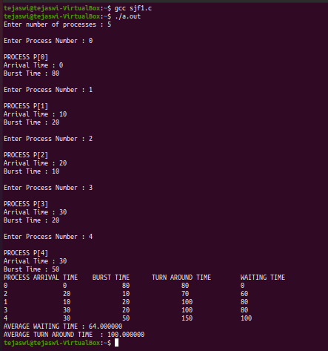

SRTF

#include<stdio.h>
int main(){
int n,i,j,k,t,total=0;
int small=10000;
float awt=0.0,atat=0.0;
printf("Enter total number of processes : ");
scanf("%d",&n);
int at[n],bt[n],tat[n],wt[n],p[100],finish[n],waiting[n];
for(i=0;i<n;i++){
printf("\nPROCESS[%d]",i);
printf("\nArrival time : ");
scanf("%d",&at[i]);
printf("Burst time : ");
scanf("%d",&bt[i]);
waiting[i]=0;
total+=bt[i];
}
//sorting the arrival time in ascending order
for(i=0;i<n;i++){
for(j=i+1;j<n;j++){
if(at[i]>at[j]){
t=at[i];
at[i]=at[j];
at[j]=t;

t=bt[i];
bt[i]=bt[j];
bt[j]=t;
}
}
}
for(i=0;i<total;i++){
small=100;
for(j=0;j<n;j++){
if((bt[j]!=0) && (at[j]<=i) && (bt[j]<small)){
small=bt[j];
k=j;//keep track of the process with shortest burst time
}
}
bt[k]--;
p[i]=k;
}
k=0;
for(i=0;i<total;i++){
for(j=0;j<n;j++){
if(p[i]==j){
finish[j]=i;//keep track of the completion time of processes
waiting[j]++;
}
}
}
printf("\nPROCESS\t\tARRIVAL TIME\tTURN AROUND TIME\n");
for(i=0;i<n;i++){
printf("%d\t\t%d\t\t%d\n",i,at[i],(finish[i] - at[i]) + 1);
awt+= (((finish[i] + 1) - waiting[i]) - at[i]);

atat+= ((finish[i] - at[i]) + 1);
}
printf("\n AVERAGE TURN AROUND TIME: %f\n AVERAGE WAITING TIME : %f\n",(atat / n), (awt / n));

return 0;}
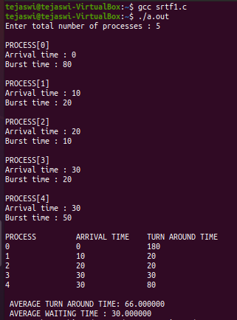

RR
#include<stdio.h>

int main()
{
int i, n, total = 0, x, counter = 0, time_quantum;
int wait_time = 0, turnaround_time = 0;
float average_wait_time, average_turnaround_time;
printf("\nEnter Number of Process : ");
scanf("%d", &n);
int at[n], bt[n], temp[n];

x = n;
for(i = 0; i < n; i++)
{
printf("\nPROCESS[%d]", i);

printf("\nArrival Time : ");

scanf("%d", &at [i]);

printf("Burst Time : ");

scanf("%d", &bt [i]);

temp[i] = burst_time[i];
}

printf("\nEnter Time Quantum : ");
scanf("%d", &time_quantum);
printf("\nProcess \tBurst Time\t Turnaround Time\t Waiting Time\n");
for(total = 0, i = 0; x != 0;)
{
if(temp[i] <= time_quantum && temp[i] > 0)
{
total = total + temp[i];
temp[i] = 0;
counter = 1;
}
else if(temp[i] > 0)
{
temp[i] = temp[i] - time_quantum;
total = total + time_quantum;
}
if(temp[i] == 0 && counter == 1)
{
x--;
printf("%d\t\t%d\t\t %d\t\t\t%d\n", i , bt[i], total - at[i], total - at[i] - bt[i]);
wait_time = wait_time + total - at[i] - bt[i];
turnaround_time = turnaround_time + total - at[i];
counter = 0;
}
if(i == n - 1)
{
i = 0;
}
else if(at[i + 1] <= total)
{
i++;
}
else
{
i = 0;
}
}

average_wait_time = wait_time * 1.0 / n;
average_turnaround_time = turnaround_time * 1.0 / n;
printf("\nAVERAGE TURN AROUND TIME : %f\n", average_turnaround_time);
printf("\nAVERAGE WAITING TIME : %f\n", average_wait_time);

return 0;
}
